**IMAGE PREPROCESSING**

**TEAM ID: PNT2022TMID47880**

**PROJECT NAME: FERTILIZER RECOMMENDATION SYSTEM FOR**

**DISEASE PREDICTION**

**Image Processing :**

Image Processing is a method to convert an image into digit form and perform some operation on it , in order to get an enhanced image or to extract some useful information from it.

It is a type of signal Dispensation in which input is image, Video frames or Photography and Output may be image or its Characteristics.

**Digital Image:**

A Digital image is a representation of a two dimensional image as a finite set of digital values called picture or pixels.

Pixel Value Typically Represent graylevels, colors,height ect.

**Image formats Includes:**

1 sample per point (B&W or Grayscales)

3 samples per point(Red, Green and Blue)

4 samples per point (Red, Green, Blue and Alpha)

**Image Processing in Deep Learning:**

Artificial Intelligences Computer Vision can interact with a image data types like image classification, object localization, Object Detection, Segmentation.

Usually of computer Vision Using an Deep Learning Algorithms like OpenCV, Pose Estimation Python Libraries ect.

In Deep Learning working has been on Neural Network which can interact and Extract the feature from Images.

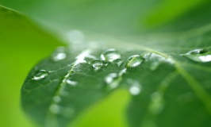 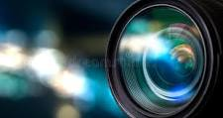 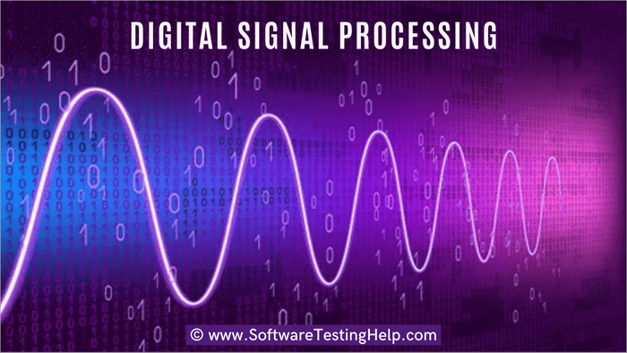 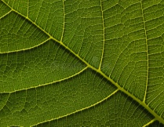

Normal image Captured sent to Particular System to Focus Processed image

**Case Study Of The Model Building In Deep Learning:**

In Training Deep Learning Model Requires an high image Dataset to train an deep learning model. But in case of low of small dataset can convert into Huge dataset by using the image Processing Techniques. By Increasing the Image Dataset by Annotation the image.

**Annotation:**

Data annotations is the categorized and labeling of data for AI applications. Training data must be properly categorized and annoted for a specific use case. With high-quality, human-powered data annotation, companies can build and improve AI implementations.

Image annotation for deep Learning is mainly done for Object detection with more precision. 3D Cuboid Annotation,Sematic Segmentation and polygon annotation are used to annotate the image using the right tool to make the objects well-define in the image for neural network analysis in deep learning.